

Appropriation (Parliamentary Departments) Act 1999-2000

No. 48, 1999

Appropriation (Parliamentary Departments) Act 1999-2000

No. 48, 1999

An Act to appropriate money out of the Consolidated Revenue Fund for certain expenditure in relation to the Parliamentary Departments in respect of the year ending on 30 June 2000, and for related purposes

Contents
Part 1—Preliminary 1
1 Short title 2
2 Commencement 2
3 Definitions 2
4 Notional payments, receipts etc. 4
Part 2—Basic appropriations 5
5 Summary of basic appropriations 5
6 Departmental items—basic appropriation 5
7 Administered items—basic appropriation 6
8 Departmental capital items—basic appropriation 6
Part 3—Additions to basic appropriations 7
9 Net appropriations 7
10 Departmental items—adjustments and borrowings 7
11 Advance to the responsible Presiding Officer—unforeseen expenses etc. 7
12 Comcover receipts 8
Part 4—Miscellaneous 10
13 Crediting amounts to Special Accounts 10
14 Appropriation of the Consolidated Revenue Fund 10
Schedule—Services for which money is appropriated 11

Appropriation (Parliamentary Departments) Act 1999-2000
No. 48, 1999

An Act to appropriate money out of the Consolidated Revenue Fund for certain expenditure in relation to the Parliamentary Departments in respect of the year ending on 30 June 2000, and for related purposes
[Assented to 30 June 1999]

The Parliament of Australia enacts:

Part 1—Preliminary

1 Short title
This Act may be cited as the Appropriation (Parliamentary Departments) Act 1999-2000.

2 Commencement
This Act commences on the day on which it receives the Royal Assent.

3 Definitions
(1) In this Act, unless the contrary intention appears:
administered item means an amount set out in the Schedule opposite an outcome of a Parliamentary Department under the heading “Administered Expenses”.
Agency has the same meaning as in the Financial Management and Accountability Act 1997.
Appropriation Bill means the Bill for this Act.
Chief Executive has the same meaning as in the Financial Management and Accountability Act 1997.
Note: Each Parliamentary Department is an Agency for the purposes of the Financial Management and Accountability Act 1997.
current year means the financial year ending on 30 June 2000.
departmental capital item means an amount set out in the Schedule in relation to a Parliamentary Department:
(a) opposite the heading “Equity Injections”; or
(b) opposite the heading “Loans”; or
(c) opposite the heading “Carryover from previous years”.
departmental expenses includes payments for the acquisition of assets.
departmental item means the total amount set out in the Schedule in relation to a Parliamentary Department under the heading “Departmental Outputs”.
Note: The amounts set out opposite outcomes, under the heading “Departmental Outputs”, are “notional”. They are not part of the item, and do not in any way restrict the scope of the expenditure authorised by the item.
Finance Minister means the Minister administering this Act.
item means any of the following:
(a) a departmental item;
(b) an administered item;
(c) a departmental capital item.
Parliamentary Department means any of the following:
(a) the Department of the Senate;
(b) the Department of the House of Representatives;
(c) the Department of the Parliamentary Library;
(d) the Department of the Parliamentary Reporting Staff;
(e) the Joint House Department.
Portfolio Budget Statements means the Portfolio Budget Statements that were tabled in the Senate or the House of Representatives in relation to the Appropriation Bill.
President means the President of the Senate.
responsible Presiding Officer means:
(a) in relation to the Department of the Senate—the President; or
(b) in relation to the Department of the House of Representatives—the Speaker; or
(c) in relation to the Department of the Parliamentary Library—the President and the Speaker together; or
(d) in relation to the Department of the Parliamentary Reporting Staff—the President and the Speaker together; or
(e) in relation to the Joint House Department—the President and the Speaker together.
section 31 agreement means an agreement under section 31 of the Financial Management and Accountability Act 1997.
Speaker means the Speaker of the House of Representatives.
Special Account has the same meaning as in the Financial Management and Accountability Act 1997.
(2) For the purposes of section 6, expenditure on departmental outputs is taken to be departmental expenses.

4 Notional payments, receipts etc.
For the purposes of this Act, notional transactions between Agencies are to be treated as if they were real transactions.
Note: This section applies, for example, to a “payment” between Agencies that are both part of the Commonwealth. One of the effects of this section is that the payment will be debited from an appropriation for the paying Agency, even though no payment is actually made from the Consolidated Revenue Fund.

Part 2—Basic appropriations

5 Summary of basic appropriations
The total of the items specified in the Schedule is $159,226,000.
Note: Items in the Schedule can be increased under Part 3 of this Act.

6 Departmental items—basic appropriation
(1) For a departmental item for a Parliamentary Department, the Finance Minister may issue out of the Consolidated Revenue Fund amounts that do not exceed, in total, the amount specified in the item.
Note: Generally, the Finance Minister is permitted, but not obliged, to issue the amounts out of the Consolidated Revenue Fund. However, subsection (3) imposes an obligation on the Finance Minister to issue the amounts in certain circumstances.
(2) An amount issued out of the Consolidated Revenue Fund for a departmental item may only be applied for the departmental expenses of the Parliamentary Department.
Note: A departmental item may be used to acquire assets. However, the acquisition of new assets will usually be funded from a departmental capital item.
(3) If a departmental item for a Parliamentary Department includes provision for payment of remuneration and allowances to the holder of:
(a) a public office (within the meaning of the Remuneration Tribunal Act 1973); or
(b) an office specified in a Schedule to the Remuneration and Allowances Act 1990;
then the Finance Minister, under subsection (1), must issue out of the Consolidated Revenue Fund, under that item, amounts that are sufficient to pay the remuneration and allowances and must apply the amounts for that purpose.

7 Administered items—basic appropriation
(1) For an administered item for an outcome of a Parliamentary Department, the Finance Minister may issue out of the Consolidated Revenue Fund amounts that do not exceed, in total, the lesser of:
(a) the amount specified in the item; and
(b) the amount determined by the Finance Minister to be the administered expenses incurred by the Parliamentary Department in the current year in relation to the item.
(2) An amount issued out of the Consolidated Revenue Fund for an administered item for an outcome may only be applied for expenditure for the purpose of carrying out activities for the purpose of contributing to achieving that outcome.
Note: An administered item may be used to acquire assets. However, the acquisition of new assets will usually be funded from an administered capital item.
(3) If the Portfolio Budget Statements indicate that activities of a particular kind were intended to be treated as activities in respect of a particular outcome, then expenditure for the purpose of carrying out those activities is taken to be expenditure for the purpose of contributing to achieving the outcome.

8 Departmental capital items—basic appropriation
(1) For a departmental capital item for a Parliamentary Department, the Finance Minister may issue out of the Consolidated Revenue Fund amounts that do not exceed, in total, the amount specified in the item.
(2) An amount issued out of the Consolidated Revenue Fund for a departmental capital item may only be applied for the departmental expenses of the Parliamentary Department.

Part 3—Additions to basic appropriations

9 Net appropriations
(1) If a section 31 agreement applies to a departmental item, then the amount specified in the item is taken to be increased in accordance with the agreement, and on the conditions set out in the agreement.
(2) For the purposes of section 31 of the Financial Management and Accountability Act 1997, each departmental item in the Schedule is taken to be marked “net appropriation”.

10 Departmental items—adjustments and borrowings
(1) The responsible Presiding Officer may determine that the amount specified in a departmental item is to be increased by an amount specified in the determination.
(2) The total of the amounts determined under this section for the Department of the Senate cannot be more than $200,000.
(3) The total of the amounts determined under this section for the Department of the House of Representatives cannot be more than $200,000.
(4) The total of the amounts determined under this section for all the other Parliamentary Departments together cannot be more than $200,000.
(5) The responsible Presiding Officer must give the Parliament details of amounts determined under this section.

11 Advance to the responsible Presiding Officer—unforeseen expenses etc.
(1) This section applies if:
- a Parliamentary Department has incurred, or is likely to incur, an expense (the extra expense) during the current year in relation to an item (the insufficient item) for the Department; and
(b) the responsible Presiding Officer is satisfied that:
(i) the expense was unforeseen until after the last day on which it was practicable to provide for the extra expense in the Appropriation Bill before that Bill was introduced into the House of Representatives; or
(ii) because of an erroneous omission or understatement, provision for the extra expense was not made in the Appropriation Bill; and
(c) the responsible Presiding Officer considers that there is an urgent need to increase the insufficient item to make provision for the extra expense.
(2) The amount of the insufficient item is taken to be increased by such amount (if any) as the responsible Presiding Officer determines, up to the amount of the extra expense.
(3) The total of the amounts determined under this section for the Department of the Senate cannot be more than $300,000.
(4) The total of the amounts determined under this section for the Department of the House of Representatives cannot be more than $300,000.
(5) The total of the amounts determined under this section for all the other Parliamentary Departments together cannot be more than $1 million.
(6) The responsible Presiding Officer must give the Parliament details of amounts determined under this section.

12 Comcover receipts
(1) This section applies whenever an amount (the Comcover payment) is debited from The Comcover Account in respect of a payment to a Parliamentary Department.
(2) Amounts totalling the full amount of the Comcover payment must be added to an item or items for the Parliamentary Department.
(3) The items and respective amounts are to be determined by the responsible Presiding Officer. In making a determination, the responsible Presiding Officer must comply with any written directions given by the Finance Minister.
(4) The responsible Presiding Officer may delegate his or her powers under this section to the Chief Executive of the Parliamentary Department.

Part 4—Miscellaneous

13 Crediting amounts to Special Accounts
If any of the purposes of a Special Account is a purpose that is covered by an item (whether or not the item expressly refers to the Special Account), then amounts may be debited against the appropriation for that item and credited to that Special Account.

14 Appropriation of the Consolidated Revenue Fund
The Consolidated Revenue Fund is appropriated as necessary for the purposes of this Act.

Schedule—Services for which money is appropriated
Note: See Sections 5 and 14
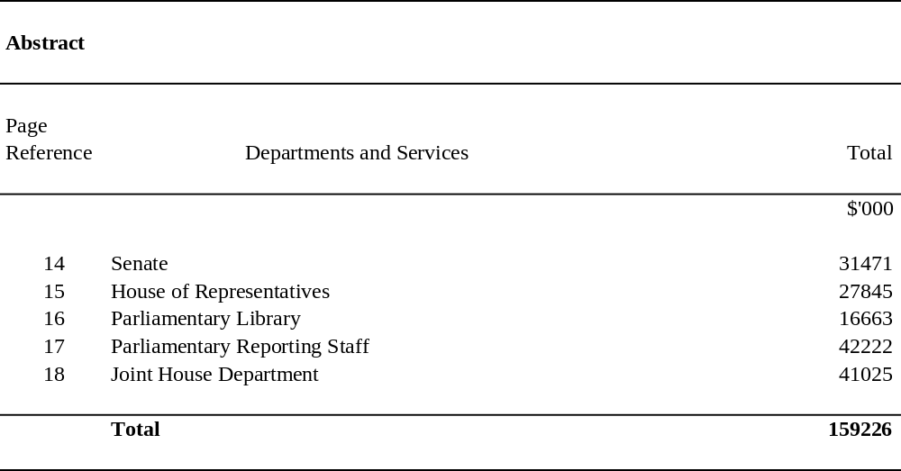

SUMMARY
Appropriation (light figures) – 1999-2000
Estimated Expenses (italic figures) – 1998-1999
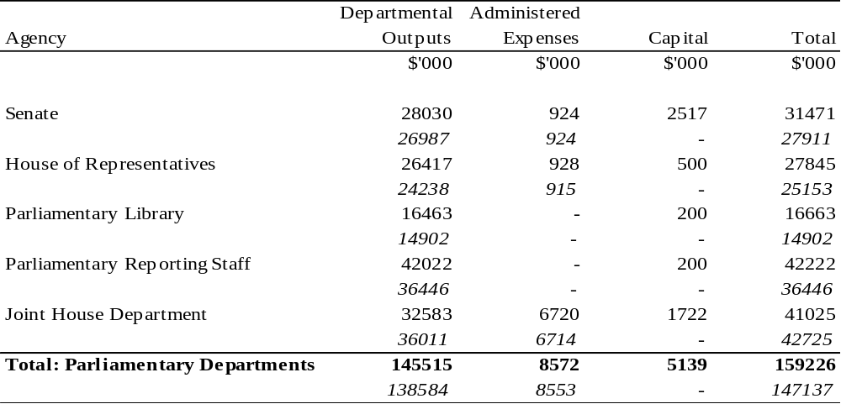
SENATE
Appropriation (light figures) – 1999-2000
Estimated Expenses (italic figures) – 1998-1999
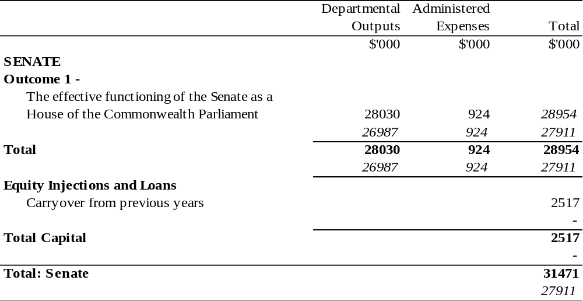
HOUSE OF REPRESENTATIVES
Appropriation (light figures) – 1999-2000
Estimated Expenses (italic figures) – 1998-1999
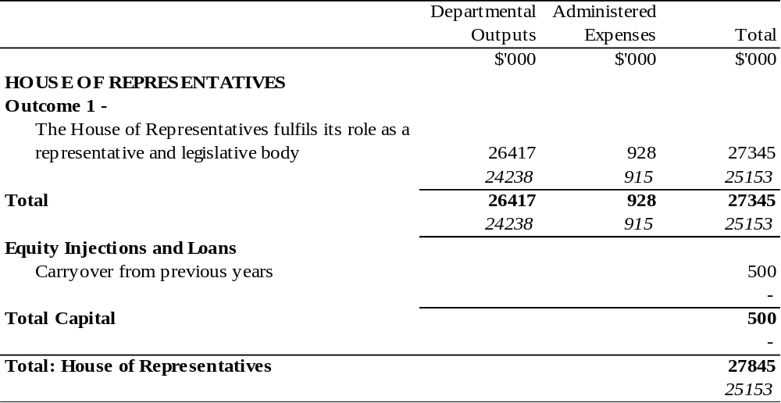
PARLIAMENTARY LIBRARY
Appropriation (light figures) – 1999-2000
Estimated Expenses (italic figures) – 1998-1999
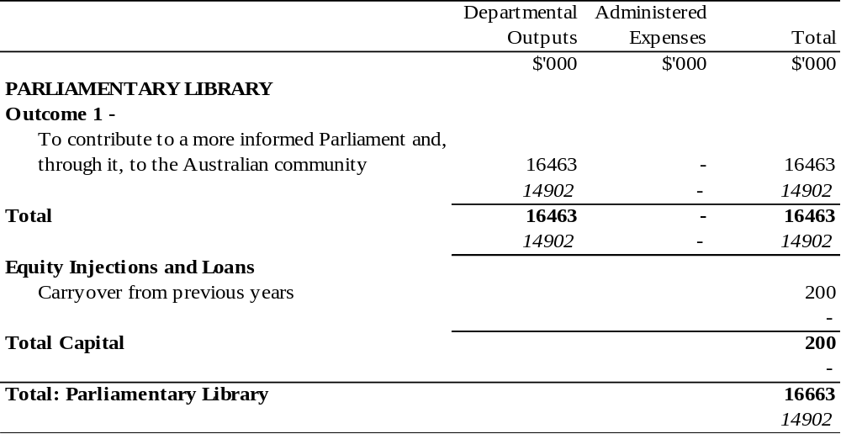
PARLIAMENTARY REPORTING STAFF
Appropriation (light figures) – 1999-2000
Estimated Expenses (italic figures) – 1998-1999
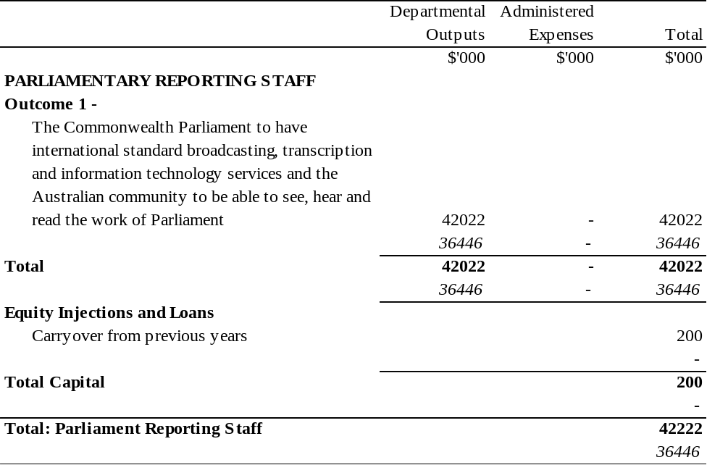
JOINT HOUSE DEPARTMENT
Appropriation (light figures) – 1999-2000
Estimated Expenses (italic figures) – 1998-1999
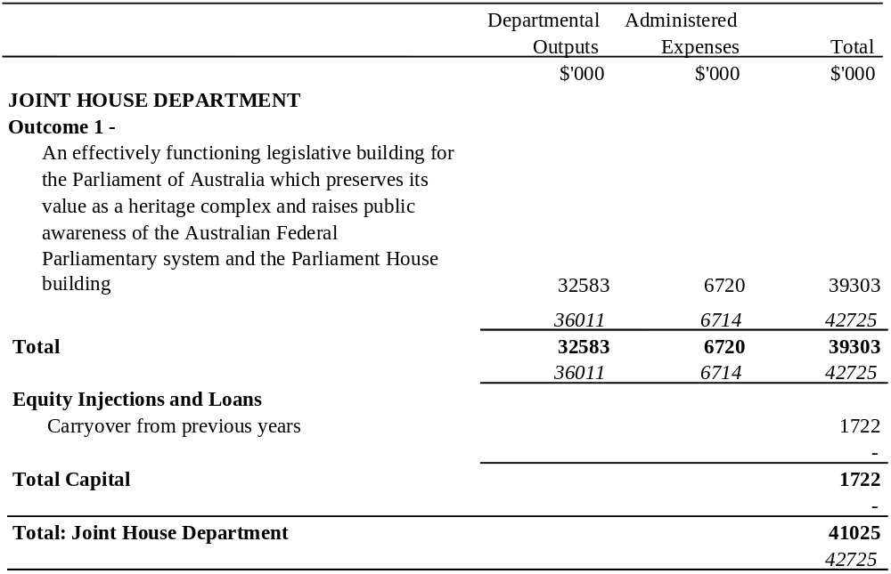
(82/99)
[Minister’s second reading speech made in—
House of Representatives on 11 May 1999
Senate on 28 June 1999]

